ASSIGNMENT 04

TOPIC: SKILL AND JOB RECOMMENDER

TEAM MEMBERS: G.NANDISH

J.NIROSH KUMAR

M.PRASAN KUMAR

R.SARAVANAN

1.create ten tables in IBM2 db2 and insert data by using insert query:

======================================================================

1.db2 create table professional.employee(id int, name

varchar(50),jobrole varchar(30),joindate date,

salary double) in ts1

Isert queries:

db2 insert into professional.customer(custid, fullname, phone)

values(100,'ravi','9898989')

db2 insert into professional.customer(custid, fullname, phone)

values(100,'ravi','9898989')

(101,'krathi','87996659')

(102,'gopal','768678687')

(103,'mani','9898989')

(104,'shilpa','87996659')

(105,'meena','768678687')

(106,'praveen','9898989')

(107,'srinivas','87996659')

(108,'magesh','768678687')

2.CREATE TABLE recipes (

recipe_id INT NOT NULL,

recipe_name VARCHAR(30) NOT NULL,

PRIMARY KEY (recipe_id),

UNIQUE (recipe_name)

);

INSERT QUERIES:

INSERT INTO recipes

(recipe_id, recipe_name)

VALUES

(1,"Tacos"),

(2,"Tomato Soup"),

(3,"Grilled Cheese")

(4,"chicken biriyani")

(5,"mutton biriyani")

(6,"shawarma")

(7,"egg noodles")

(8,"BBQ")

(9,"VEG BIRIYANI")

(10,"sandwitch");

3.CREATE TABLE ingredients (

ingredient_id INT NOT NULL,

ingredient_name VARCHAR(30) NOT NULL,

ingredient_price INT NOT NULL,

PRIMARY KEY (ingredient_id),

UNIQUE (ingredient_name)

);

INSERT QUERIES:

INSERT INTO ingredients

(ingredient_id, ingredient_name, ingredient_price)

VALUES

(1, "Beef", 5),

(2, "Lettuce", 1),

(3, "Tomatoes", 2),

(4, "Taco Shell", 2),

(5, "Cheese", 3),

(6, "Milk", 1),

(7, "Bread", 2);

4.CREATE TABLE recipe_ingredients (

recipe_id int NOT NULL,

ingredient_id INT NOT NULL,

amount INT NOT NULL,

PRIMARY KEY (recipe_id,ingredient_id)

);

INSERT QUERIES:

INSERT INTO recipe_ingredients

(recipe_id, ingredient_id, amount)

VALUES

(1,1,1),

(1,2,2),

(1,3,2),

(1,4,3),

(1,5,1),

(2,3,2),

(2,6,1),

(3,5,1),

(3,7,2),

(1,3,2),

(1,4,3),

(1,5,1),

(2,3,2),

(2,6,1),

(1,3,2),

(1,4,3),

(1,5,1),

(2,3,2),

(2,6,1);

5.CREATE TABLE groceries (

id INTEGER PRIMARY KEY,

name TEXT,

quantity INTEGER );

INSERT QUERIES:

INSERT INTO groceries

VALUES

(1, "Bananas", 4)

(2, "Peanut Butter", 1)

(3, "Dark chocolate bars", 2)

(4, "DRAGON FRUIT", 1)

(5, "pine apple", 4)

(6, "gova", 1)

(7, "apple", 2)

(8, "orange", 1)

(9, "pumkin", 3)

(10, "grapes", 1)

(11 "watermelon", 1)

6.db2 create table professional(id int, name

varchar(50),jobrole varchar(30),joindate date,

salary double) in ts1

Isert queries:

db2 insert into professional(custid, fullname, phone)

values(100,'ravi','9898989')

db2 insert into professional(custid, fullname, phone)

values(1,'balaji','9898989')

(2,'kiran','87996659')

(3,'dinesh','768678687')

(4,'chidu','9898989')

(5,'naveenraj','87996659')

(6,'jaipraveen','768678687')

(7,'surya','9898989')

(8,'sandeep','87996659')

(9,'karankumar','768678687')

7.CREATE TABLE fooditems (

recipe_id INT NOT NULL,

recipe_name VARCHAR(30) NOT NULL,

PRIMARY KEY (recipe_id),

UNIQUE (recipe_name)

);

INSERT QUERIES:

INSERT INTO recipes

(recipe_id, recipe_name)

VALUES

(1,"lemon rice"),

(2,"noodles"),

(3,"Grilled chicken")

(4,"chicken biriyani")

(5,"mutton biriyani")

(6,"curd rice")

(7,"egg noodles")

(8,"masal poori")

(9,"vaangi baath")

(10,"masala magi");

8.CREATE TABLE items (

ingredient_id INT NOT NULL,

ingredient_name VARCHAR(30) NOT NULL,

ingredient_price INT NOT NULL,

PRIMARY KEY (ingredient_id),

UNIQUE (ingredient_name)

);

INSERT QUERIES:

INSERT INTO ingredients

(ingredient_id, ingredient_name, ingredient_price)

VALUES

(1, "chilli powder", 5),

(2, "cooriender powder", 1),

(3, "turmeric", 2),

(4, "salt", 2),

(5, "pepper powder", 3),

(6, "sugar", 1),

(7, "food colour", 2);

9.CREATE TABLE vehicles(

id INTEGER PRIMARY KEY,

name TEXT,

quantity INTEGER );

INSERT QUERIES:

INSERT INTO groceries

VALUES

(1, "yamaha", 4)

(2, "suzuki", 1)

(3, "access", 2)

(4, "splender", 1)

(5, "aaaa", 4)

(6, "bbbb", 1)

(7, "mahendra", 2)

(8, "cccc", 1)

(9, "dddd", 3)

(10, "eeee", 1)

(11 "tvs", 1)

10.CREATE TABLE sweets (

recipe_id INT NOT NULL,

recipe_name VARCHAR(30) NOT NULL,

PRIMARY KEY (recipe_id),

UNIQUE (recipe_name)

);

INSERT QUERIES:

INSERT INTO recipes

(recipe_id, recipe_name)

VALUES

(1,"jamun"),

(2,"faludha"),

(3,"custud")

(4,"paal kova")

(5,"mysoor pakh")

(6,"cream bun")

(7,"sweet pufs")

(8,"badusha")

(9,"laddoo")

2.PERFORM UPDATE DELETE SELECT QUERIES IN 10 TABLES:

======================================================

1.professional.employee

UPDATE professional.employee

SET name='pooja'

WHERE id=102';

select * from professional.employee

delete * from table where name="karthi"

2.recipies

UPDATE recipies

SET recipiename='vangibaath'

WHERE id=1';

select * from recipies;

delete * from recipies where name="soup"

3.ingredients

UPDATE ingredients

SET ingredient_name="chicken"

WHERE id=1';

select * from ingrediens;

delete * from ingredients where name="BBQ";

4.recipe_ingredients

UPDATE recipe_ingredients

SET recipe_id=2;

WHERE amount='2';

select * from recipe_ingredients;

delete * from recipe_ingredients where ingredient_id='6';

5.groceries

UPDATE groceries

SET name=sapota

WHERE id='2';

select * from groceries;

delete * from groceries where name=pumkin;

6. professional

UPDATE professional

SET name=manmadan;

WHERE id='2';

select * from professional;

delete * from professional where name=karankumar;

7.fooditems

UPDATE fooditems

SET recipe_name=gravy chicken;

WHERE amount='2';

select * from fooditems ;

delete * from fooditems where name='masala magi';

8.items

UPDATE items

SET ingredient_name="soya saas"

WHERE id=10';

select * from items;

delete * from items where name="sugar";

9. vehicles

UPDATE vehicles

SET name='ffff'

WHERE id='5';

select * from vehicles;

delete * from vehicles where name='bbbb';

10.sweets

UPDATE sweets

SET recipiename='boondi'

WHERE id='3';

select * from sweets;

delete * from sweets where name="sweet pufs";

3.LOAD EXCEL COMMA SEPARATED FILE TO IBMDB2

1.create ten tables in IBM2 db2 and insert data by using insert query:

======================================================================

1.db2 create table professional.employee(id int, name

varchar(50),jobrole varchar(30),joindate date,

salary double) in ts1

Isert queries:

db2 insert into professional.customer(custid, fullname, phone)

values(100,'ravi','9898989')

db2 insert into professional.customer(custid, fullname, phone)

values(100,'ravi','9898989')

(101,'krathi','87996659')

(102,'gopal','768678687')

(103,'mani','9898989')

(104,'shilpa','87996659')

(105,'meena','768678687')

(106,'praveen','9898989')

(107,'srinivas','87996659')

(108,'magesh','768678687')

2.CREATE TABLE recipes (

recipe_id INT NOT NULL,

recipe_name VARCHAR(30) NOT NULL,

PRIMARY KEY (recipe_id),

UNIQUE (recipe_name)

);

INSERT QUERIES:

INSERT INTO recipes

(recipe_id, recipe_name)

VALUES

(1,"Tacos"),

(2,"Tomato Soup"),

(3,"Grilled Cheese")

(4,"chicken biriyani")

(5,"mutton biriyani")

(6,"shawarma")

(7,"egg noodles")

(8,"BBQ")

(9,"VEG BIRIYANI")

(10,"sandwitch");

3.CREATE TABLE ingredients (

ingredient_id INT NOT NULL,

ingredient_name VARCHAR(30) NOT NULL,

ingredient_price INT NOT NULL,

PRIMARY KEY (ingredient_id),

UNIQUE (ingredient_name)

);

INSERT QUERIES:

INSERT INTO ingredients

(ingredient_id, ingredient_name, ingredient_price)

VALUES

(1, "Beef", 5),

(2, "Lettuce", 1),

(3, "Tomatoes", 2),

(4, "Taco Shell", 2),

(5, "Cheese", 3),

(6, "Milk", 1),

(7, "Bread", 2);

4.CREATE TABLE recipe_ingredients (

recipe_id int NOT NULL,

ingredient_id INT NOT NULL,

amount INT NOT NULL,

PRIMARY KEY (recipe_id,ingredient_id)

);

INSERT QUERIES:

INSERT INTO recipe_ingredients

(recipe_id, ingredient_id, amount)

VALUES

(1,1,1),

(1,2,2),

(1,3,2),

(1,4,3),

(1,5,1),

(2,3,2),

(2,6,1),

(3,5,1),

(3,7,2),

(1,3,2),

(1,4,3),

(1,5,1),

(2,3,2),

(2,6,1),

(1,3,2),

(1,4,3),

(1,5,1),

(2,3,2),

(2,6,1);

5.CREATE TABLE groceries (

id INTEGER PRIMARY KEY,

name TEXT,

quantity INTEGER );

INSERT QUERIES:

INSERT INTO groceries

VALUES

(1, "Bananas", 4)

(2, "Peanut Butter", 1)

(3, "Dark chocolate bars", 2)

(4, "DRAGON FRUIT", 1)

(5, "pine apple", 4)

(6, "gova", 1)

(7, "apple", 2)

(8, "orange", 1)

(9, "pumkin", 3)

(10, "grapes", 1)

(11 "watermelon", 1)

6.db2 create table professional(id int, name

varchar(50),jobrole varchar(30),joindate date,

salary double) in ts1

Isert queries:

db2 insert into professional(custid, fullname, phone)

values(100,'ravi','9898989')

db2 insert into professional(custid, fullname, phone)

values(1,'balaji','9898989')

(2,'kiran','87996659')

(3,'dinesh','768678687')

(4,'chidu','9898989')

(5,'naveenraj','87996659')

(6,'jaipraveen','768678687')

(7,'surya','9898989')

(8,'sandeep','87996659')

(9,'karankumar','768678687')

7.CREATE TABLE fooditems (

recipe_id INT NOT NULL,

recipe_name VARCHAR(30) NOT NULL,

PRIMARY KEY (recipe_id),

UNIQUE (recipe_name)

);

INSERT QUERIES:

INSERT INTO recipes

(recipe_id, recipe_name)

VALUES

(1,"lemon rice"),

(2,"noodles"),

(3,"Grilled chicken")

(4,"chicken biriyani")

(5,"mutton biriyani")

(6,"curd rice")

(7,"egg noodles")

(8,"masal poori")

(9,"vaangi baath")

(10,"masala magi");

8.CREATE TABLE items (

ingredient_id INT NOT NULL,

ingredient_name VARCHAR(30) NOT NULL,

ingredient_price INT NOT NULL,

PRIMARY KEY (ingredient_id),

UNIQUE (ingredient_name)

);

INSERT QUERIES:

INSERT INTO ingredients

(ingredient_id, ingredient_name, ingredient_price)

VALUES

(1, "chilli powder", 5),

(2, "cooriender powder", 1),

(3, "turmeric", 2),

(4, "salt", 2),

(5, "pepper powder", 3),

(6, "sugar", 1),

(7, "food colour", 2);

9.CREATE TABLE vehicles(

id INTEGER PRIMARY KEY,

name TEXT,

quantity INTEGER );

INSERT QUERIES:

INSERT INTO groceries

VALUES

(1, "yamaha", 4)

(2, "suzuki", 1)

(3, "access", 2)

(4, "splender", 1)

(5, "aaaa", 4)

(6, "bbbb", 1)

(7, "mahendra", 2)

(8, "cccc", 1)

(9, "dddd", 3)

(10, "eeee", 1)

(11 "tvs", 1)

10.CREATE TABLE sweets (

recipe_id INT NOT NULL,

recipe_name VARCHAR(30) NOT NULL,

PRIMARY KEY (recipe_id),

UNIQUE (recipe_name)

);

INSERT QUERIES:

INSERT INTO recipes

(recipe_id, recipe_name)

VALUES

(1,"jamun"),

(2,"faludha"),

(3,"custud")

(4,"paal kova")

(5,"mysoor pakh")

(6,"cream bun")

(7,"sweet pufs")

(8,"badusha")

(9,"laddoo")

2.PERFORM UPDATE DELETE SELECT QUERIES IN 10 TABLES:

======================================================

1.professional.employee

UPDATE professional.employee

SET name='pooja'

WHERE id=102';

select * from professional.employee

delete * from table where name="karthi"

2.recipies

UPDATE recipies

SET recipiename='vangibaath'

WHERE id=1';

select * from recipies;

delete * from recipies where name="soup"

3.ingredients

UPDATE ingredients

SET ingredient_name="chicken"

WHERE id=1';

select * from ingrediens;

delete * from ingredients where name="BBQ";

4.recipe_ingredients

UPDATE recipe_ingredients

SET recipe_id=2;

WHERE amount='2';

select * from recipe_ingredients;

delete * from recipe_ingredients where ingredient_id='6';

5.groceries

UPDATE groceries

SET name=sapota

WHERE id='2';

select * from groceries;

delete * from groceries where name=pumkin;

6. professional

UPDATE professional

SET name=manmadan;

WHERE id='2';

select * from professional;

delete * from professional where name=karankumar;

7.fooditems

UPDATE fooditems

SET recipe_name=gravy chicken;

WHERE amount='2';

select * from fooditems ;

delete * from fooditems where name='masala magi';

8.items

UPDATE items

SET ingredient_name="soya saas"

WHERE id=10';

select * from items;

delete * from items where name="sugar";

9. vehicles

UPDATE vehicles

SET name='ffff'

WHERE id='5';

select * from vehicles;

delete * from vehicles where name='bbbb';

10.sweets

UPDATE sweets

SET recipiename='boondi'

WHERE id='3';

select * from sweets;

delete * from sweets where name="sweet pufs";

3.LOAD EXCEL COMMA SEPARATED FILE TO IBMDB2

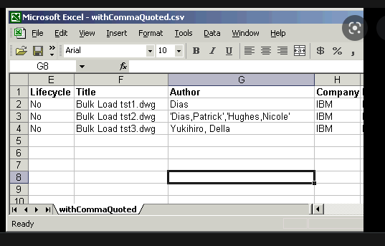

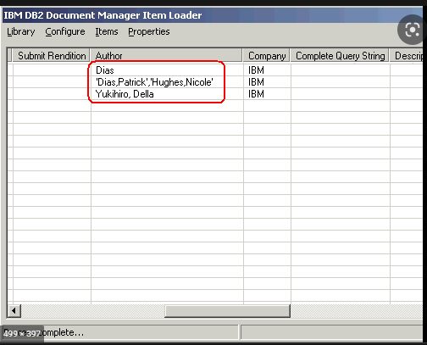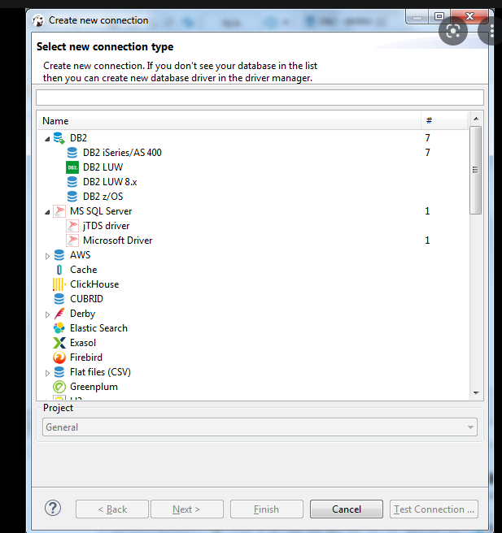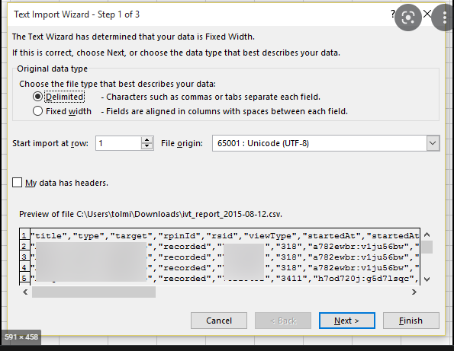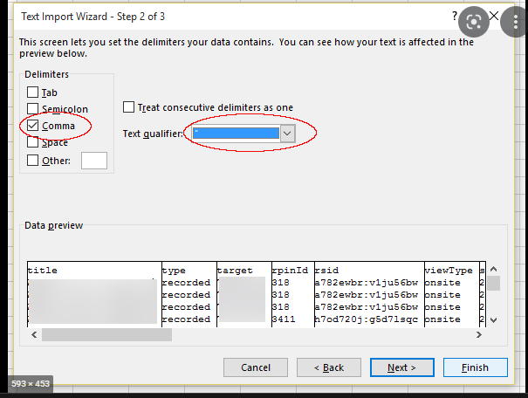

.

4.CONNECT PYTHON TO DB2

